Architecture Design Assignment

1. You are working in company XYZ required you to develop a design package for library, and develop the following diagram:
2. Class Diagram

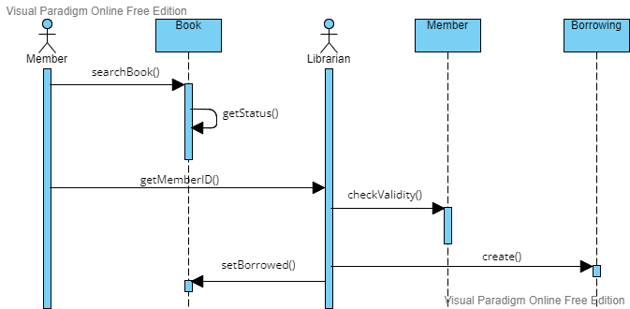

1. Sequence Diagram for borrow a book from library

